Strategy Pattern
# Source: AI Source: Provided by: [Data Path: Persons Table -> ID Column: 1, Name_En Column: Motasem Essam] -> From: [ChatGPT] on [1/23/2026]
The Strategy Pattern defines a family of algorithms, encapsulates each one, and makes them interchangeable at runtime.
👉 Think of it like choosing a payment method: you can pay by credit card, PayPal, or cash—same action, different strategies.

🔑 Key Points
# Source: AI Source: Provided by: [Data Path: Persons Table -> ID Column: 1, Name_En Column: Motasem Essam] -> From: [ChatGPT] on [1/23/2026]
• Encapsulates algorithms into separate classes
• Allows switching behavior at runtime
• Eliminates large if/else or switch statements
• Promotes open/closed principle

❌ Bad Example
# Source: AI Source: Provided by: [Data Path: Persons Table -> ID Column: 1, Name_En Column: Motasem Essam] -> From: [ChatGPT] on [1/23/2026]
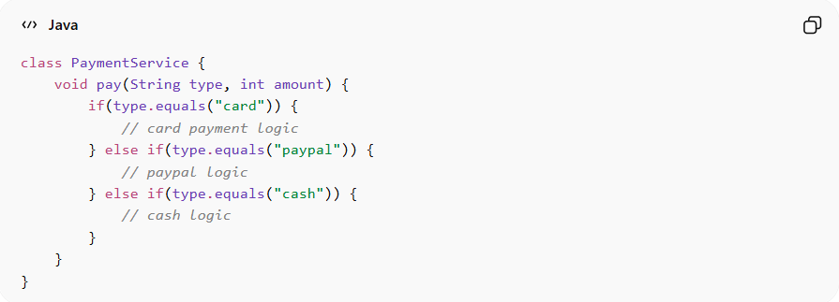
class PaymentService {
void pay(String type, int amount) {
if(type.equals("card")) {
// card payment logic
} else if(type.equals("paypal")) {
// paypal logic
} else if(type.equals("cash")) {
// cash logic
}
}
}
Problems:
• Violates Open/Closed Principle
• Hard to add new payment methods
• Code becomes complex and hard to maintain

✅ Good Example
# Source: AI Source: Provided by: [Data Path: Persons Table -> ID Column: 1, Name_En Column: Motasem Essam] -> From: [ChatGPT] on [1/23/2026]
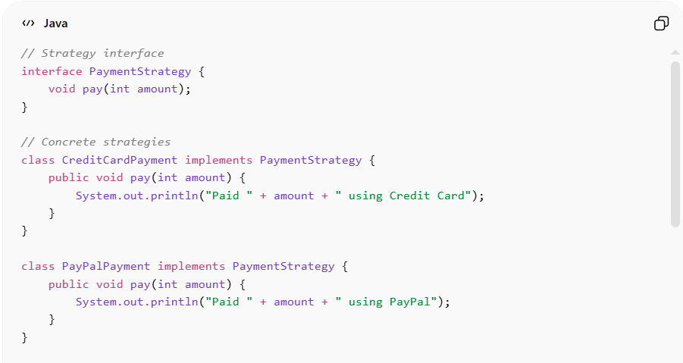
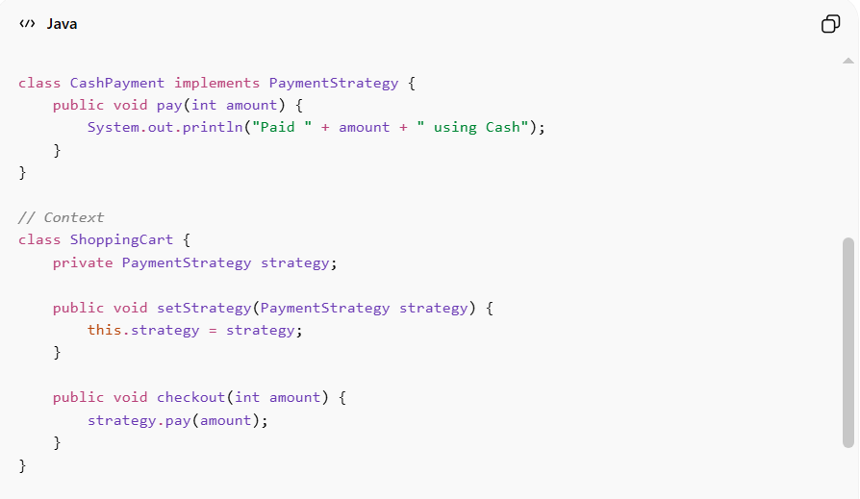
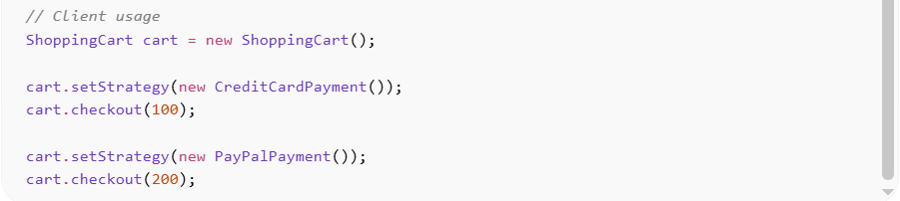
// Strategy interface
interface PaymentStrategy {
void pay(int amount);
}

// Concrete strategies
class CreditCardPayment implements PaymentStrategy {
public void pay(int amount) {
System.out.println("Paid " + amount + " using Credit Card");
}
}

class PayPalPayment implements PaymentStrategy {
public void pay(int amount) {
System.out.println("Paid " + amount + " using PayPal");
}
}

class CashPayment implements PaymentStrategy {
public void pay(int amount) {
System.out.println("Paid " + amount + " using Cash");
}
}

// Context
class ShoppingCart {
private PaymentStrategy strategy;

public void setStrategy(PaymentStrategy strategy) {
this.strategy = strategy;
}

public void checkout(int amount) {
strategy.pay(amount);
}
}

// Client usage
ShoppingCart cart = new ShoppingCart();

cart.setStrategy(new CreditCardPayment());
cart.checkout(100);

cart.setStrategy(new PayPalPayment());
cart.checkout(200);
Benefits:
• Easy to add new strategies
• Removes complex conditional logic
• Promotes clean and maintainable code
• Supports runtime flexibility

⚡ Advantages
# Source: AI Source: Provided by: [Data Path: Persons Table -> ID Column: 1, Name_En Column: Motasem Essam] -> From: [ChatGPT] on [1/23/2026]
• Algorithms can be switched at runtime
• Encourages composition over inheritance
• Improves testability and reusability
• Keeps code clean and organized

⚠️ Disadvantages
# Source: AI Source: Provided by: [Data Path: Persons Table -> ID Column: 1, Name_En Column: Motasem Essam] -> From: [ChatGPT] on [1/23/2026]
• Increases number of classes
• Client must be aware of different strategies
• Slight overhead in managing strategy objects

🛠️ Use Cases
# Source: AI Source: Provided by: [Data Path: Persons Table -> ID Column: 1, Name_En Column: Motasem Essam] -> From: [ChatGPT] on [1/23/2026]
• Payment systems – different payment methods
• Sorting algorithms – quick sort, merge sort, bubble sort
• Discount systems – seasonal, membership-based discounts
• Game AI – different behaviors (aggressive, defensive, neutral)

